**Python Advance Assignment 4**

**1. Explain the differences between Cassandra and typical databases.**

Cassandra: Cassandra is a high-performance and highly scalable distributed NoSQL database management system. Cassandra deals with unstructured data and handles a high volume of incoming data velocity. In Cassandra data is written in many locations also data come from many locations this row represents a unit of replication and the column represents a unit of storage.

RDBMS: Relational Database Management System (RDBMS) is a Database management system or software that is designed for relational databases and uses Structured Query Language (SQL) for querying and maintaining the database. It deals with structured data and handles moderate incoming data velocity. In RDBMS mainly data is written in one location also data come from one/few locations and a row represents a single record column that represents an attribute.

**2. What exactly is CQLSH?**

CQLSH (Cassandra Query Language Shell) is a command-line interface for interacting with Apache Cassandra databases using the CQL (Cassandra Query Language). It allows users to execute CQL statements to create, modify, and query data in a Cassandra cluster. CQLSH also provides various features such as autocompletion, syntax highlighting, and paging of query results, making it a useful tool for managing and analyzing Cassandra databases.

**3. Explain the Cassandra cluster idea.**

Cassandra Architecture

Some of the features of Cassandra architecture are as follows:

Cassandra is designed such that it has no master or slave nodes.

It has a ring-type architecture, that is, its nodes are logically distributed like a ring.

Data is automatically distributed across all the nodes.

Similar to HDFS, data is replicated across the nodes for redundancy.

Data is kept in memory and lazily written to the disk.

Hash values of the keys are used to distribute the data among nodes in the cluster.

A hash value is a number that maps any given key to a numeric value. For example, the string ‘ABC’ may be mapped to 101, and decimal number 25.34 may be mapped to 257. A hash value is generated using an algorithm so that the same value of the key always gives the same hash value. In a ring architecture, each node is assigned a token value, as shown in the image below:

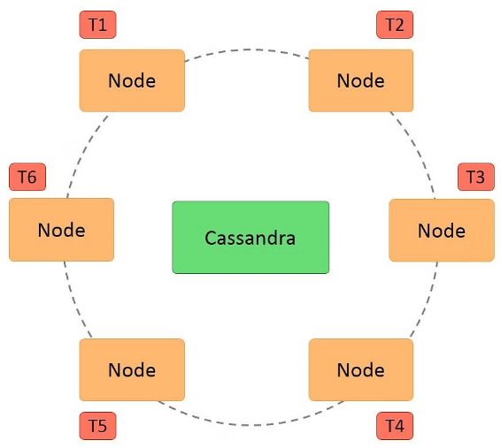

Additional features of Cassandra architecture are:

Cassandra architecture supports multiple data centers.

Data can be replicated across data centers.

We can keep three copies of data in one data center and the fourth copy in a remote data center for remote backup. Data reads prefer a local data center to a remote data center.

**4. Give an example to demonstrate the class notion.**

Classes are the user-defined blueprints that help us create an “object”. Objects are the instances of a particular class. Every other element in Python will be an object of some class, such as the string, dictionary, number(10,40), etc. will be an object of some corresponding built-in class(int, str) in Python. Objects are different copies of the class with some actual values. For example blueprint of a car can consider as class, while the models of the cars based on that blueprint, which is known as the objects(instances of the class) of the particular class.

**5. Use an example to explain the object.**

Different objects belonging to same class can have different properties. For example, Person(Human) can be treated as a class which has properties such as name, age, gender etc. Every individual can be treated as an object of the class human or Person. Each individual will have different values of the properties of class Person.Everyone will have different names, age and gender.